The example can be running in a few steps.

1. Ensure you install and configure NodeJS <https://nodejs.org/en/> on your local workstation
   1. You can check this by typing at a command window: “node --version” (without the double quotes)
2. Install the AWS SDK for JavaScript <https://aws.amazon.com/sdk-for-node-js/>
3. Create a user with programmatic access
   1. In browser, login to the AWS Console, to go IAM
   2. Click users in left navigation click “users”
   3. Click “Add user” button
   4. In Add User Windows create a new user “survey-user-pa”
   5. Tick the “Programmatic access” check box
   6. Click “Next: Permissions”

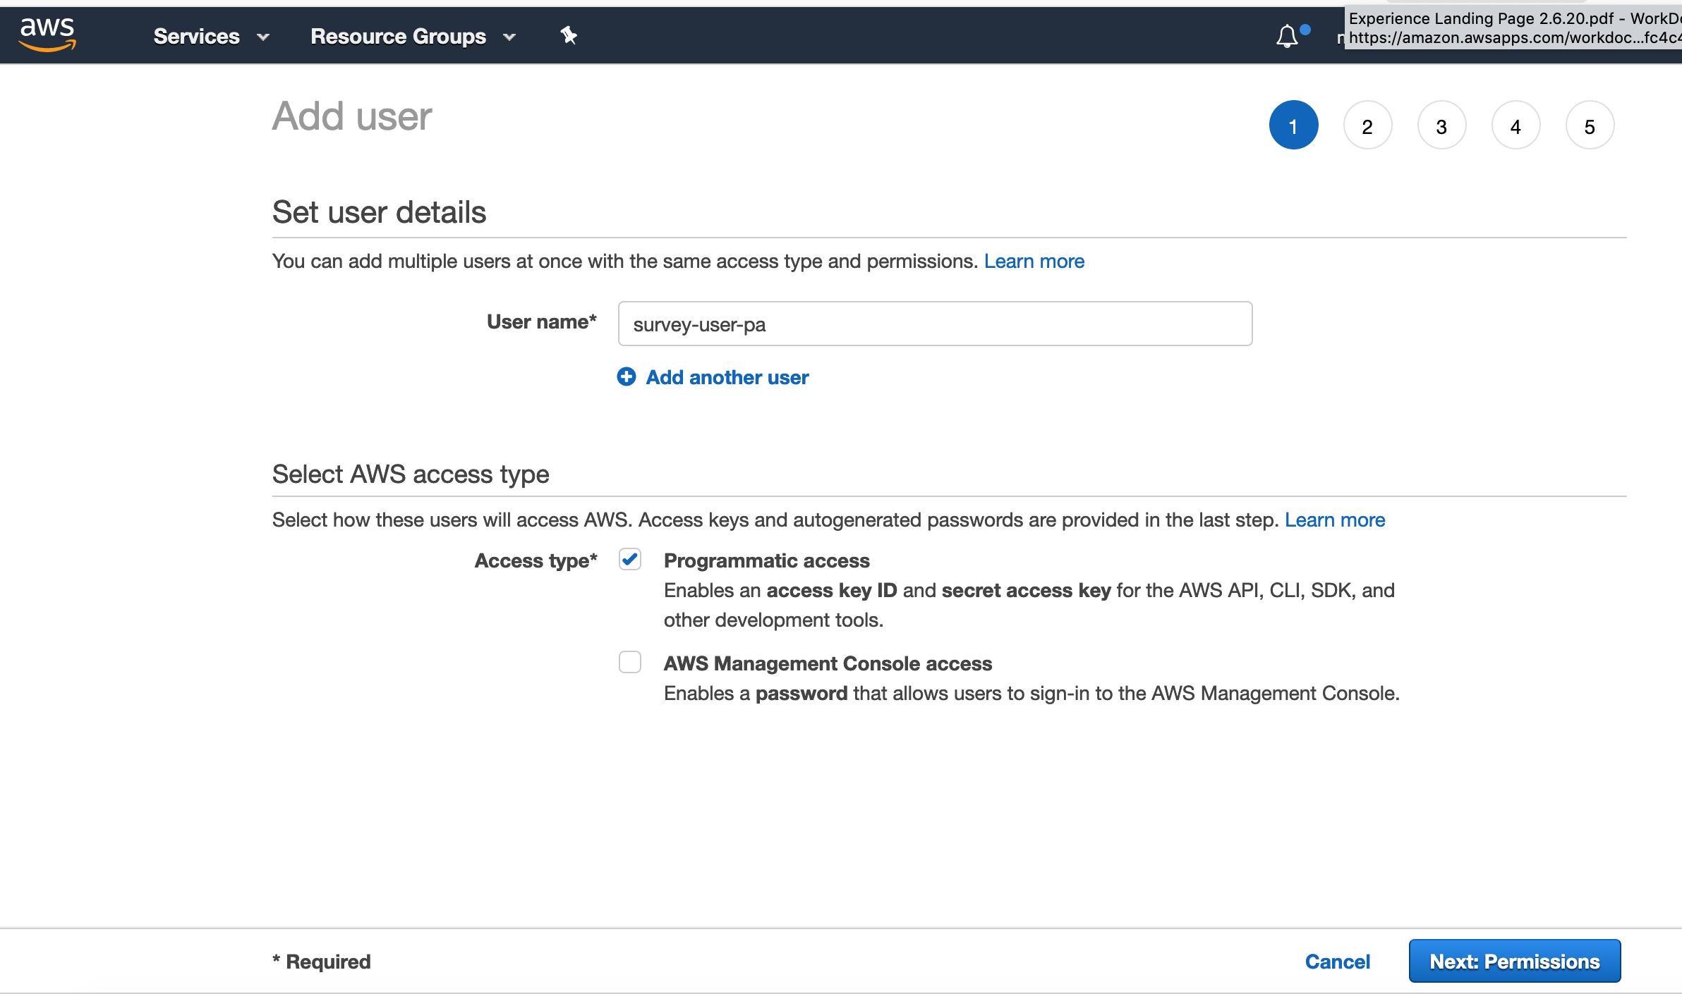

* 1. In permissions window, select “Attach existing policies directly”
     1. In the search box type “dynamo”
     2. Tick the “AmazonDynamoFullDBAccess” policy 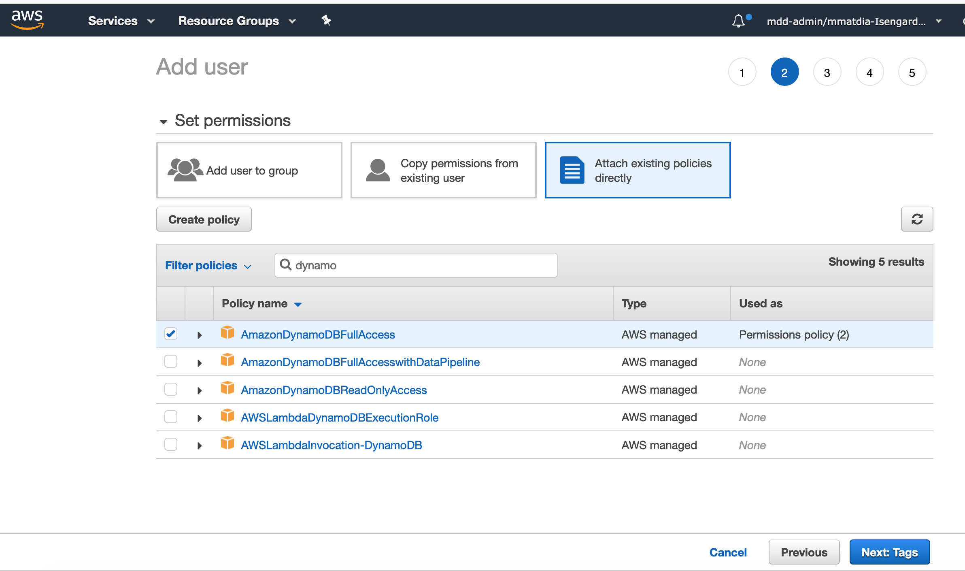
  2. Click “Next: Tags”
  3. Click “Next: Review”
  4. Click “Create User”
  5. Copy the Access Key and Secret Access Key somewhere safe (like a text file on your workstation)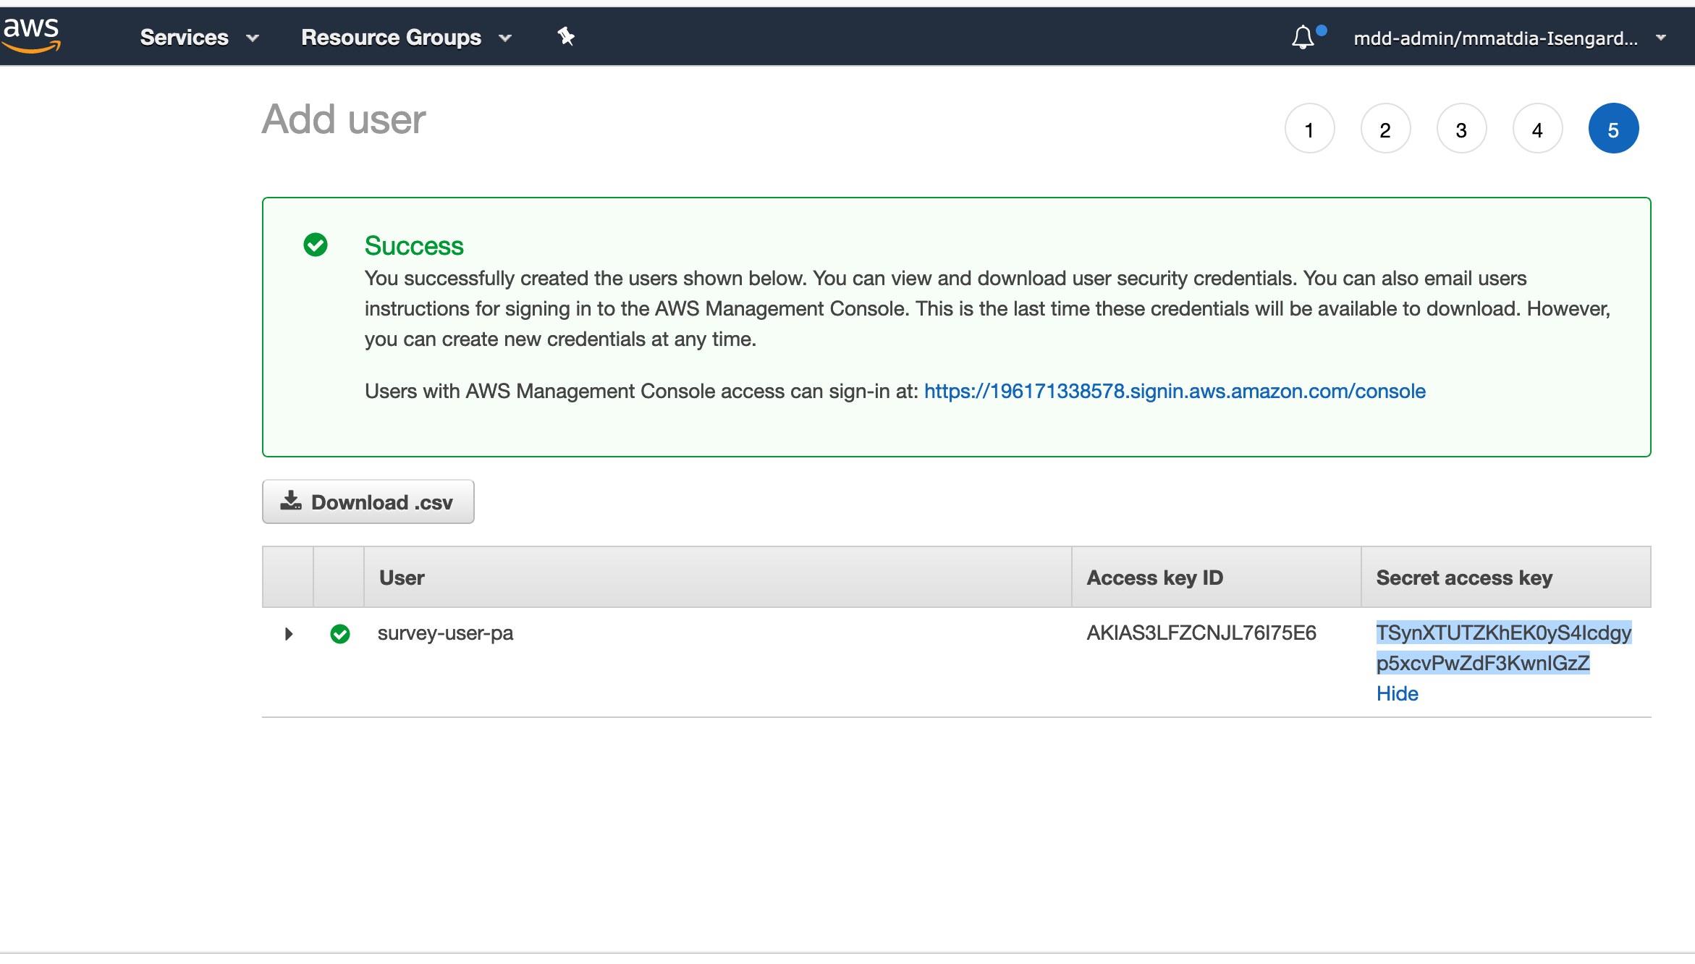

1. Configure AWS SDK:
   1. Start a command window type “AWS Configure”
   2. Enter in the AWS Access Key ID you created earlier
   3. Enter in the AWS Secret Access Key you created earlier
   4. Enter a default region name: us-east-2
   5. Default output format (you can just hit enter)
   6. You can close this window once the process completes
2. Lets create a Amazon DynamoDB Table
   1. Head back to the web browser and in the AWS account
   2. In the Services menu, type “dynamo” in the search, click DynamoDB
   3. Ensure you have selected the us-east-2 (Ohio) region in the upper right corner
   4. Click Create Table
   5. In Table Name Type “collect”
   6. In Primary Key Filed type “CRA_ID”
   7. Click Create
3. Unzip the attached file titled survey.zip
4. Open the survey directory in VSCode (File → open, select root of survey folder and click “open)
   1. From the terminal menu, select “New Terminal”
   2. This starts a terminal session in the bottom right corner of your VSCode window
5. type “npm install” (without the double quotes)
6. type “npm start” (without the double quotes) 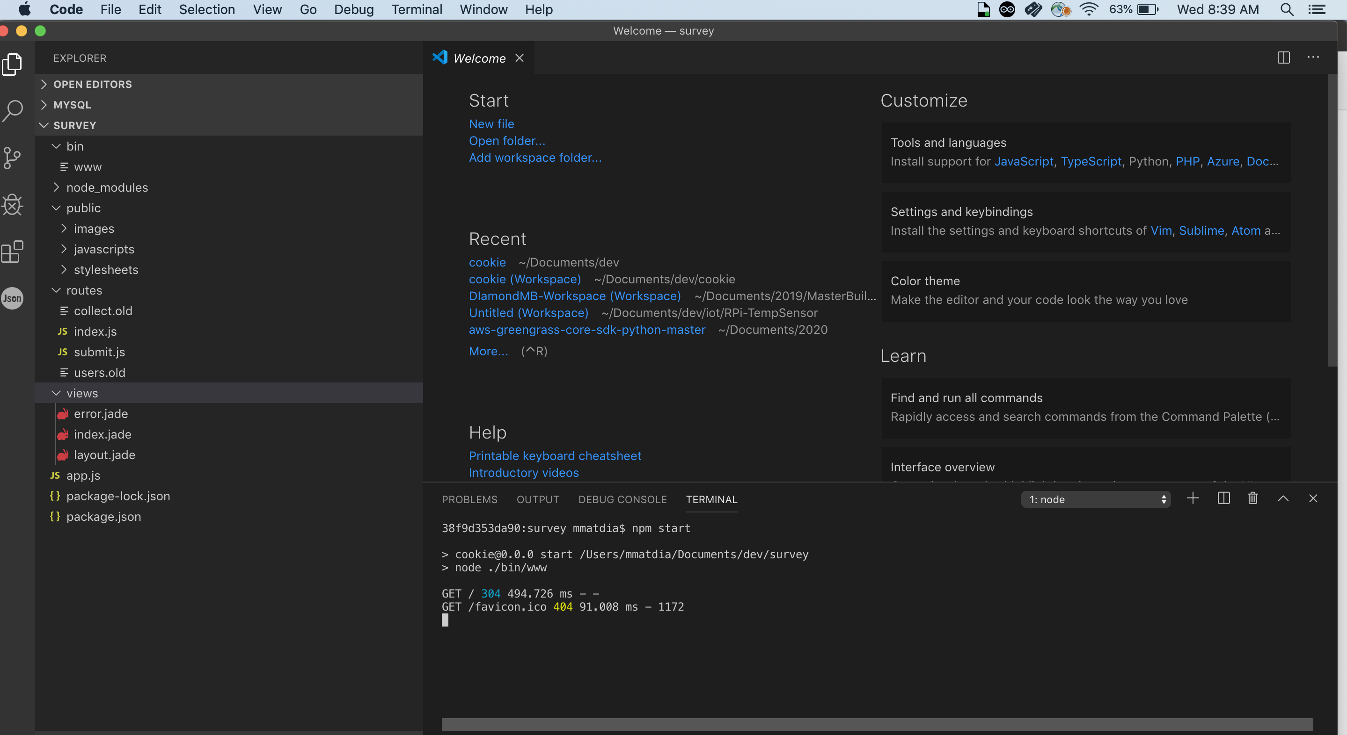
7. Test it out:
   1. In your favorite web browser, head to <http://localhost:3000> you should see the survey: 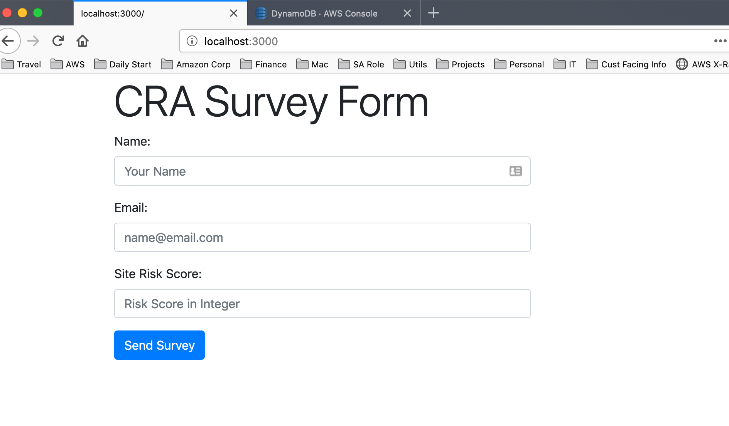
   2. After submitting sample data, you should see the data in the table in DynamoDB – Click “Table” in left Navigation, select the “Item” tab along top row
   3. Also in VSCode, the data is logged to the console